**VanPham’s Lab 1 Reflection.docx**

* Name: Van Phuc Pham
* Student Number: 000761144
* Lab Number: 1

1. **Lab Status:**

* What’s working:

+ Models were created

+ Teams Controller was created and worked correctly. Managers have fully access, Players have read only, and unauthenticated users are prevented from accessing the TeamsController.

+ Database and View were created and updated.

* What’s not working:

+ My laptop cannot work with localdb, so that I used the SQL Express instead.

1. **Three things I learned from the lab:**

* I learned how to seed the database with the roles.
* I learned how to make authentication system for ASP.NET.
* I learned how to restrict access to all authenticated users.

1. **Three areas that I need to work on based on the lab.**

* I need to revise C# systax because I have not used C# for a long time.
* I need to revise ASP.Net syntax.
* I need to follow the instructions carefully. It took me a lot of time to finish this Lab because I made mistakes.

1. **Uses Case with Screenshot and display and display the results of the Index and Create actions**
2. **Try to access Team page when I did not login**

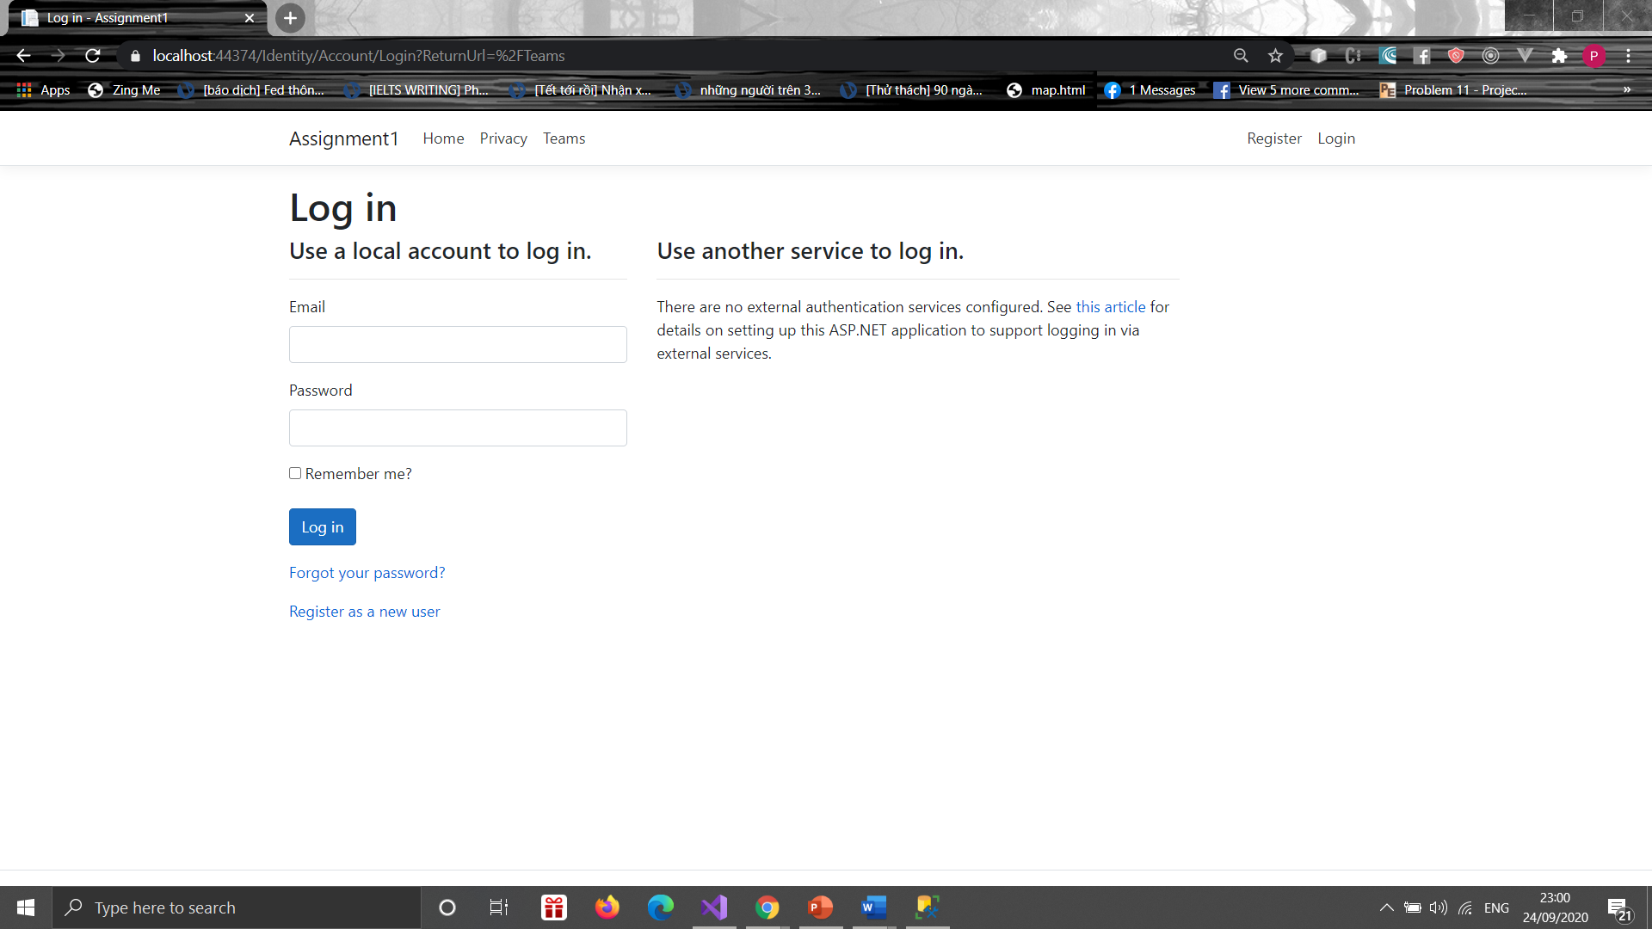

1. **Register Page**
2. **Validate user input**

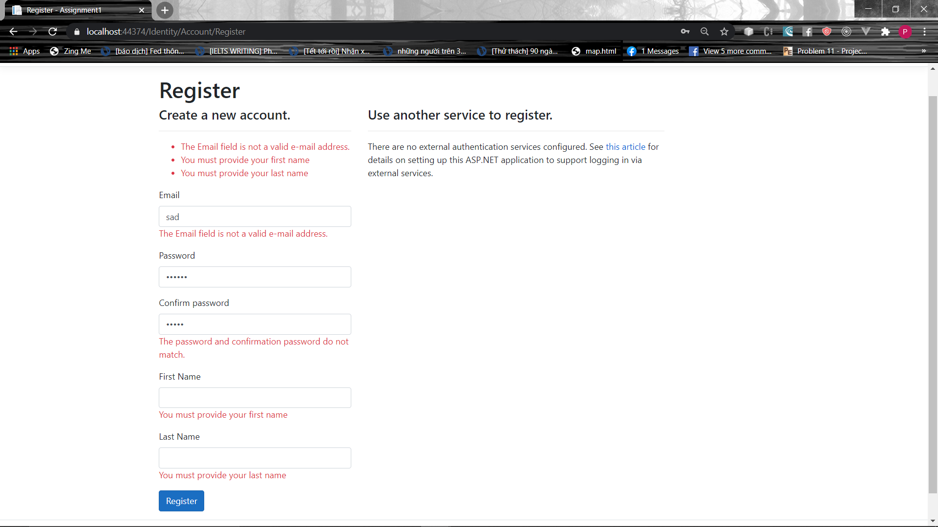

1. **Login Successfully**

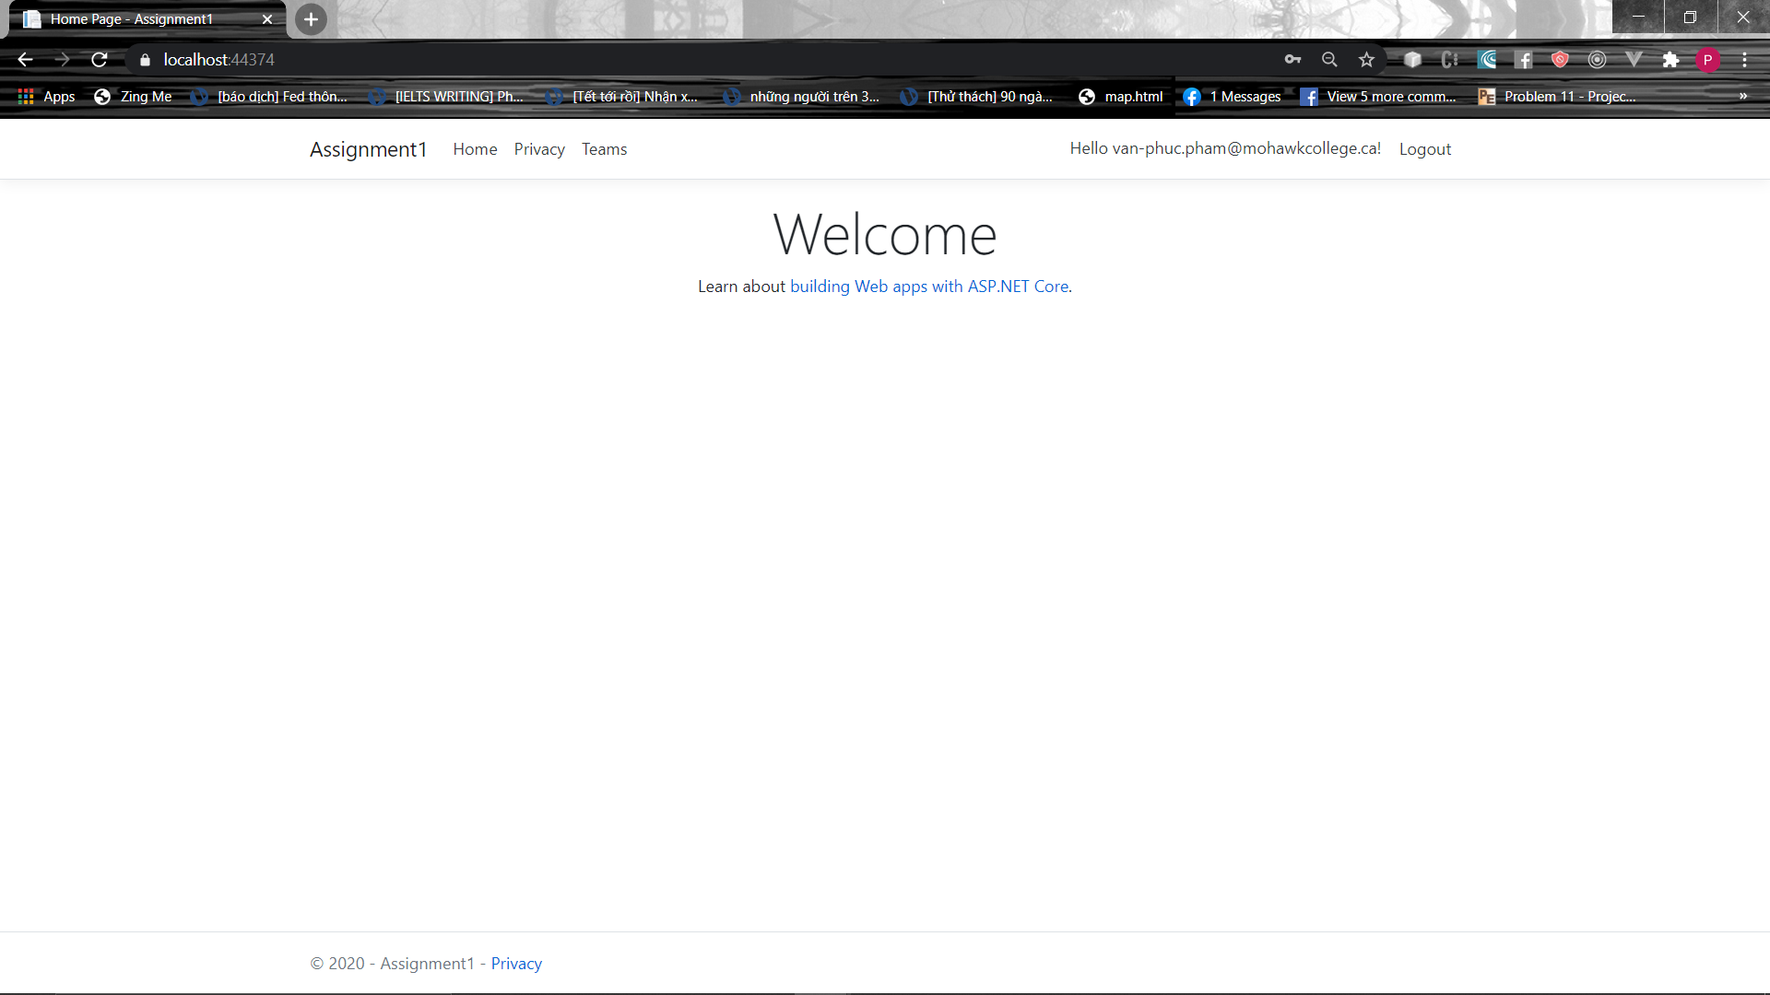

1. **Team Page**
2. **Login with a user who has not been authenticated**

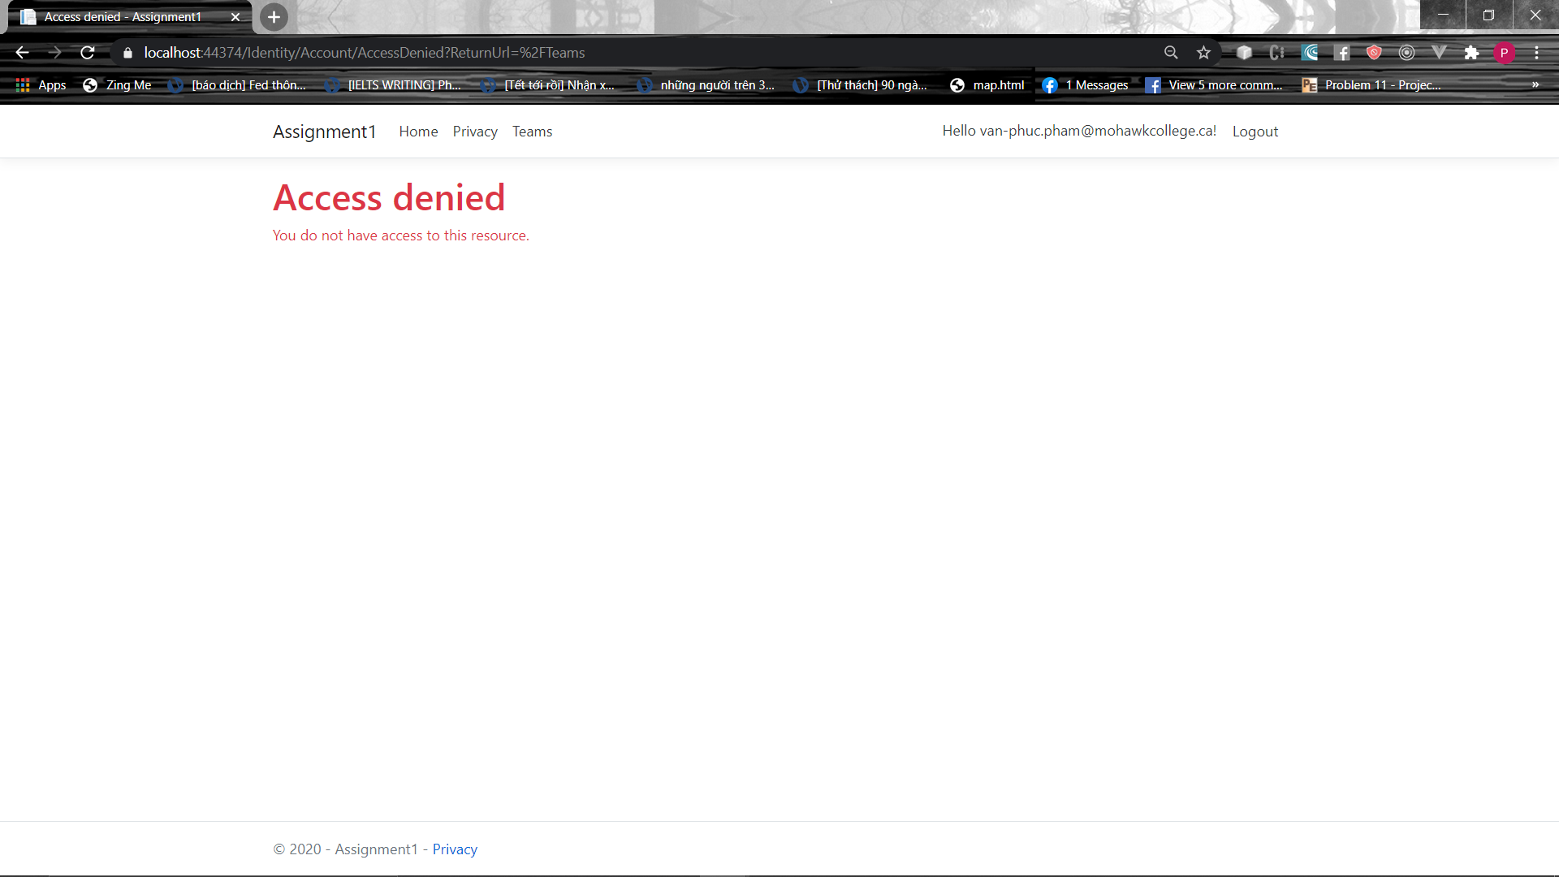

1. **Login with Manager account**

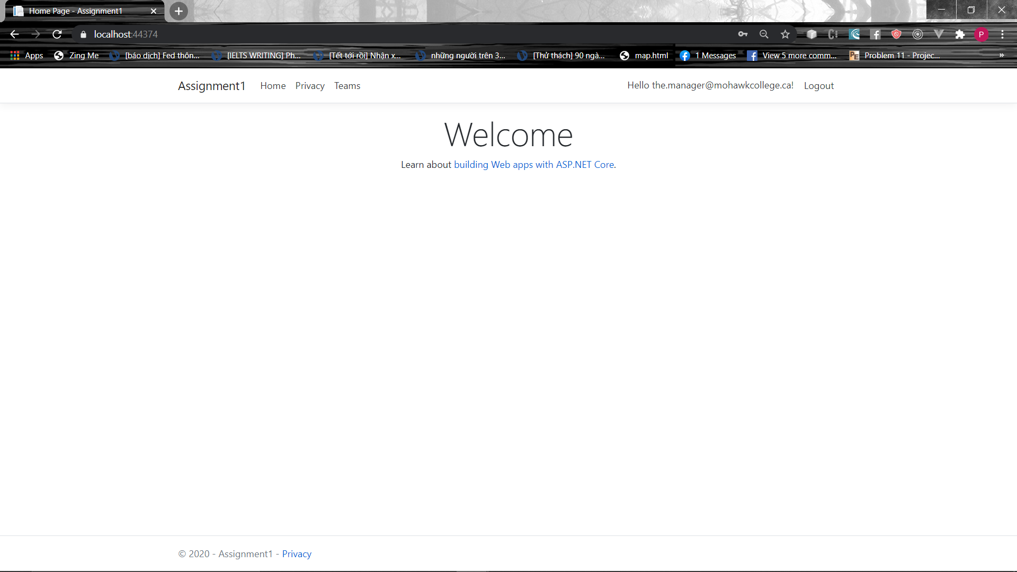

* 1. **Access Team Page**

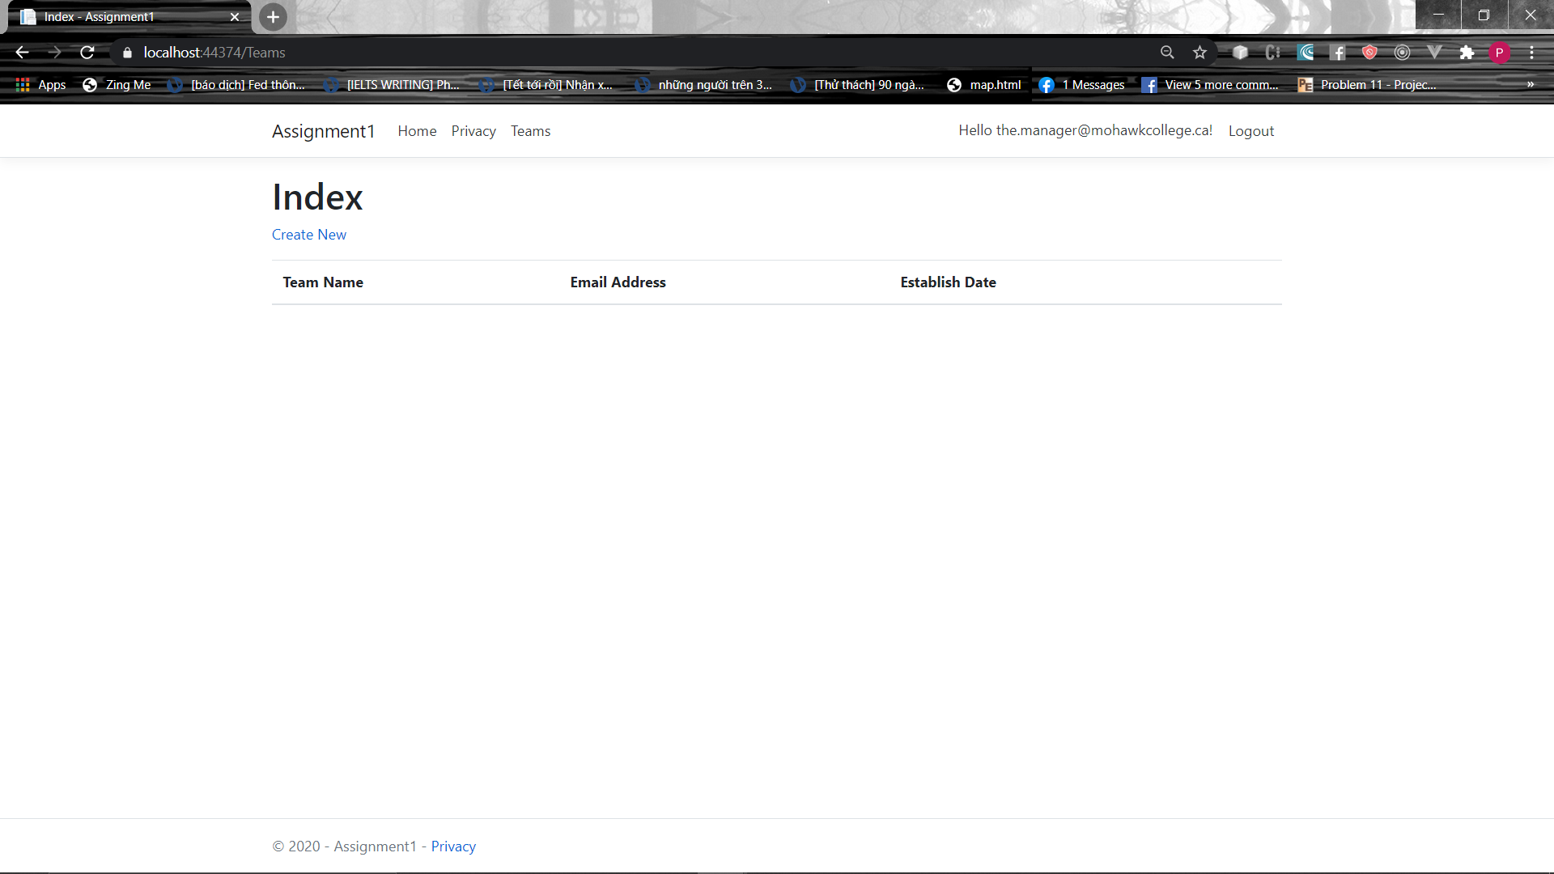

**3. Player – read only**

**3.1 Team page**

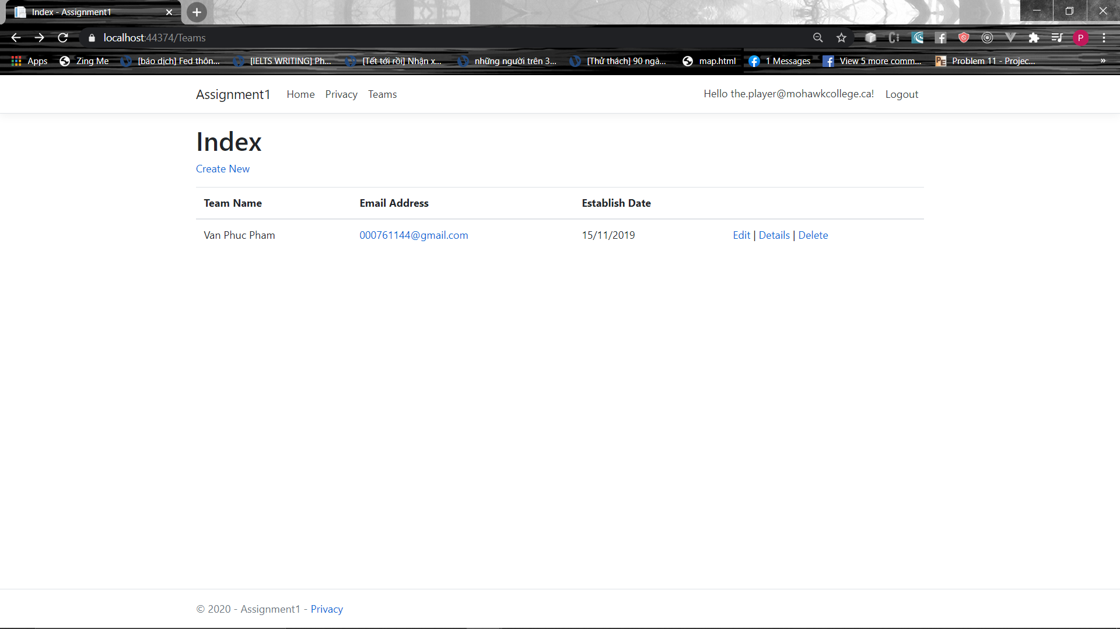

**3.2 Detail Page**



**3.3 Create Page**

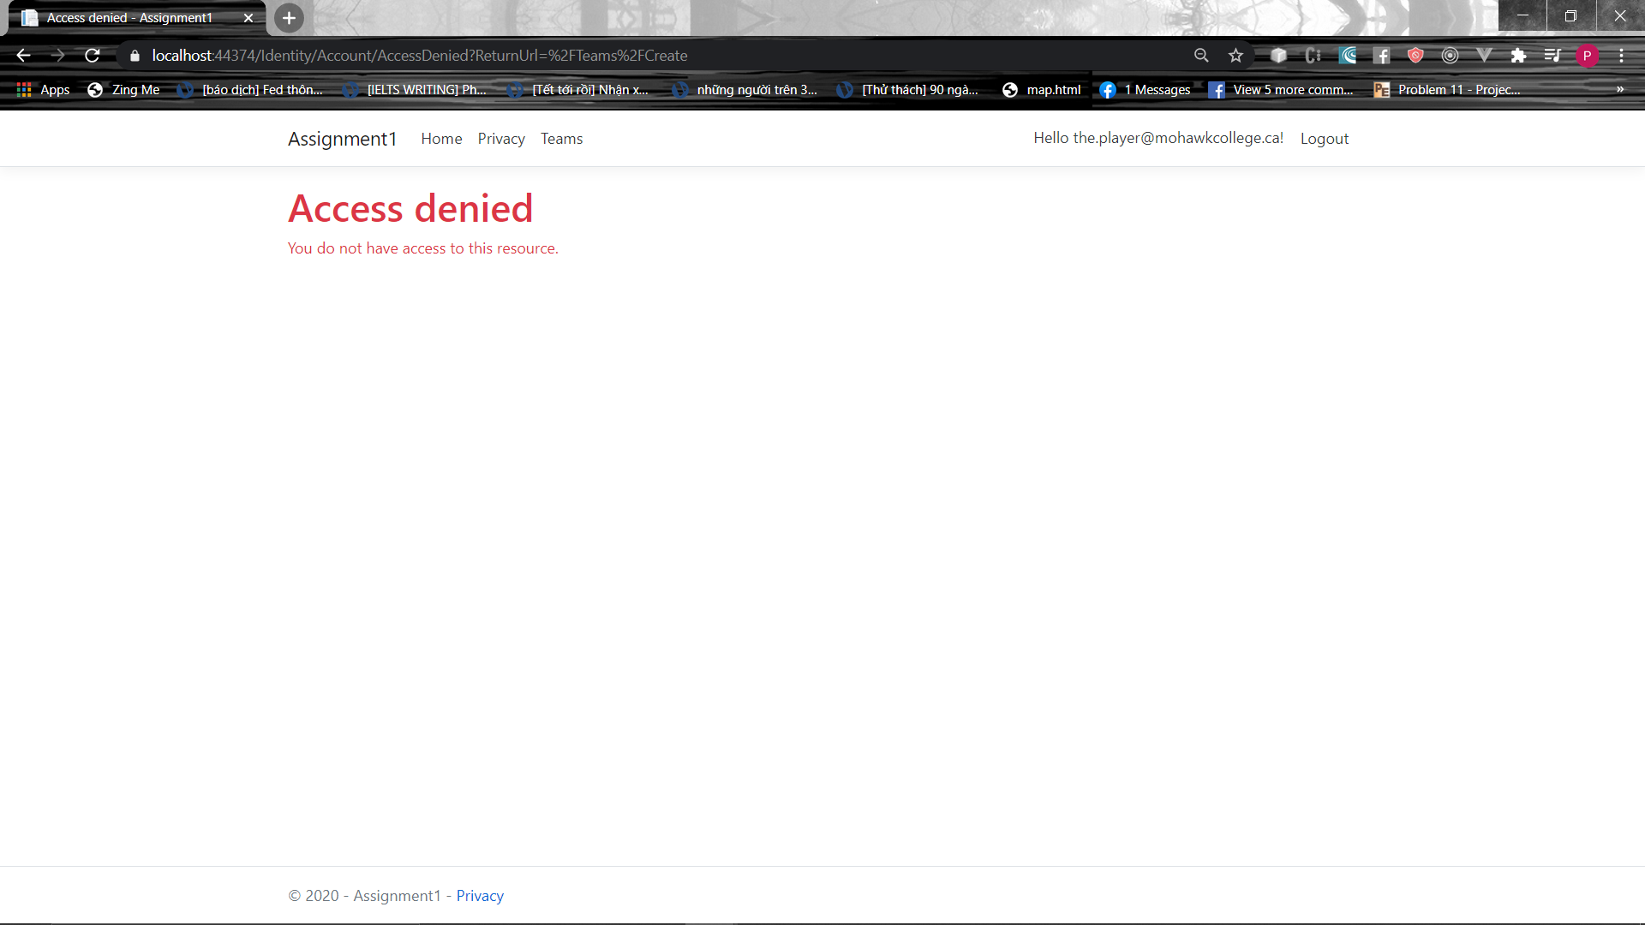

1. **Create new Team**
2. **Validation**

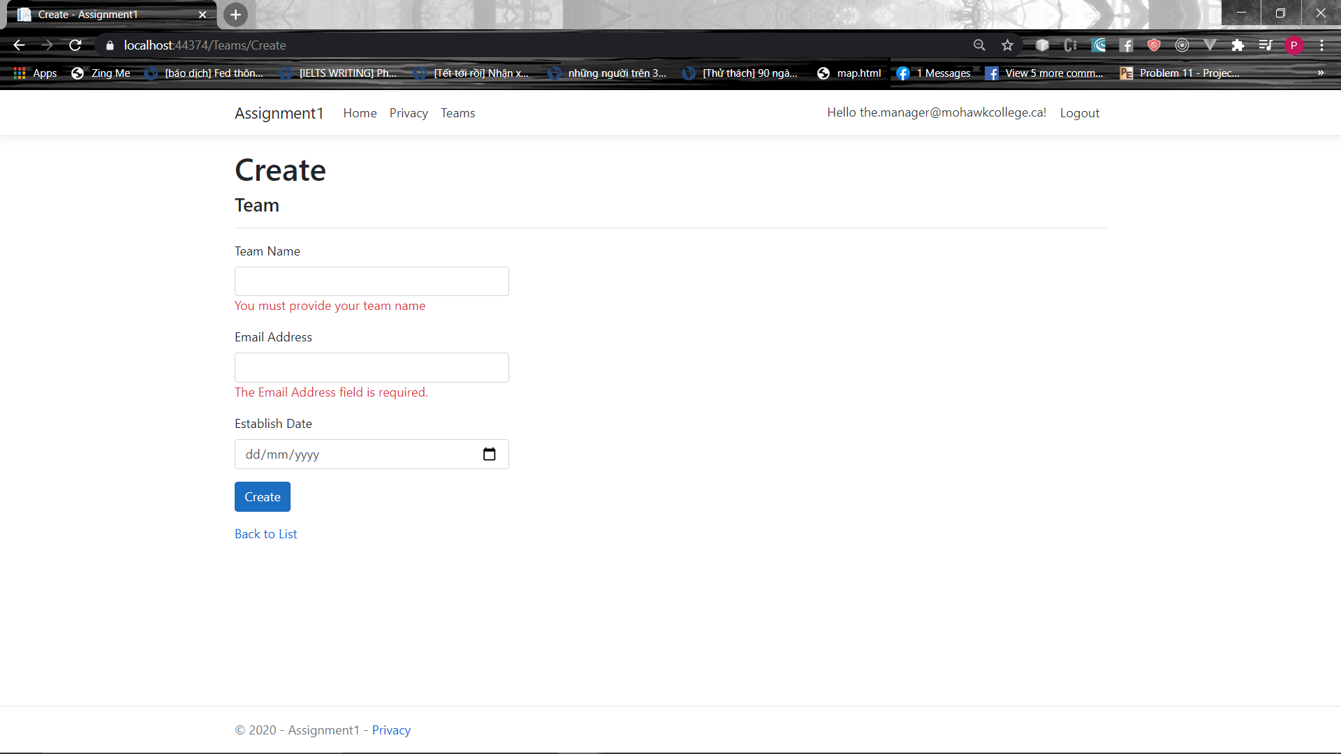

1. **Edit Page**

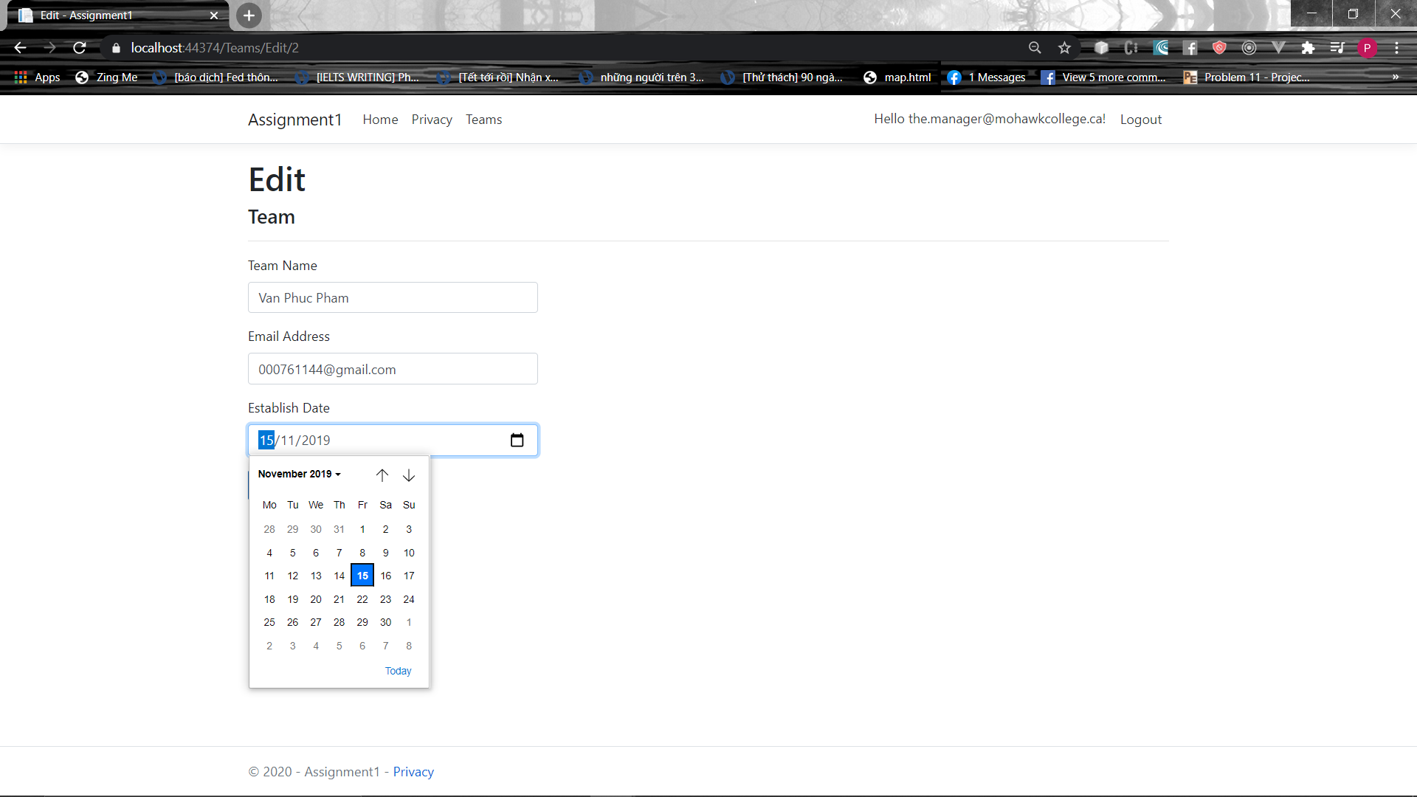

1. **Delete Page**

